**Human Resource Management (HRM)**

* Human Resource Management (HRM) is the department or function in an organization that takes care of all matters related to employees.
* This includes hiring the right people, helping them grow through training, managing their performance, paying them fairly, and ensuring they work in a safe and happy environment.
* In today’s world, no business can run well without the right people, so managing human resources has become a key part of every organization.

**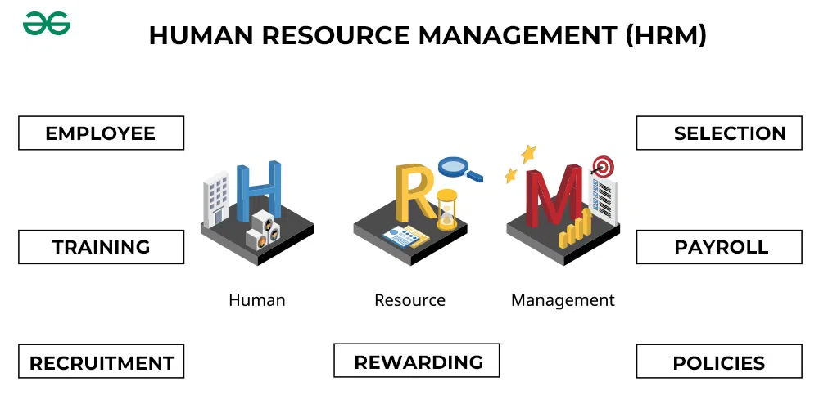  
Employee Management**

* HR keeps full details of every employee like their name, job, performance, and experience.
* It makes sure that employees are placed in the right jobs based on their skills.
* HR checks how well each employee is doing at work and gives support when needed.
* It helps solve any problems or complaints employees may have.

**What is the Recruitment Process?**

* **The recruitment process** is the set of steps a company follows to find and hire new employees.

**1. Preparing**

* The recruiter meets with the hiring manager to understand the role, required skills, qualifications, and experience.
* Based on the discussion, a clear and inclusive job description is written to attract the right candidates.
* The finalized job description is used to create job postings for company websites, job boards, and social media.

**2. Sourcing**

* Recruiters actively search for candidates through job portals, LinkedIn, employee referrals, and professional networks.
* Instead of waiting for applications, recruiters reach out directly to potential candidates who fit the profile.
* If applications are already high, sourcing may be limited or skipped based on the role’s urgency and volume.

**3. Screening**

* Resumes are reviewed to check if the candidate meets basic qualifications and experience.
* A call is made to understand the candidate’s current role, salary, notice period, and interest in the position.
* Candidates who meet the job criteria and show interest are shortlisted for the next step in the process.

**4. Selecting**

* Candidates may be asked to complete assignments or psychometric tests to evaluate their skills and mindset.
* Recruiters coordinate interviews between the candidate and the hiring manager or panel.
* Continuous updates are shared with the candidate about interview status, feedback, and next steps.

**5. Hiring**

* A final round of conversation is held to discuss salary, benefits, joining date, and other terms.
* After agreement, the recruiter prepares and sends the official offer letter.
* In some organizations, verification of past employment, education, or criminal background is conducted.

**6. Onboarding**

* Recruiters stay in touch with the candidate between offer acceptance and joining to keep them interested.
* Email IDs, workstations, and introductions with the team are arranged before the new hire’s first day.
* Once the candidate joins, formal onboarding begins with company orientation, training, and integration into the team.

**Training and Development**

* HR gives training to new employees to help them understand their job.
* It also arranges learning sessions for current employees to improve their skills.
* HR encourages employees to grow and build their careers.
* It helps people stay up-to-date with new tools, software, or work methods.

**Rewarding and Recognition**

* HR gives rewards like bonuses, gift cards, or extra leave to good performers.
* It appreciates employees by giving awards or public recognition.
* HR promotes hardworking employees to higher positions.
* These rewards make employees feel valued and keep them motivated.

**Policies**

* HR makes rules for working hours, holidays, dress code, and workplace behavior.
* These rules are the same for all employees, so everyone is treated fairly.
* Policies help avoid confusion, conflict, and unfair treatment.
* HR explains all rules clearly when someone joins the company.

**Payroll**

* HR calculates how much salary each employee should get based on their work and leaves.
* It makes sure that employees receive their salary on time.
* HR handles tax deductions, insurance, and other salary-related matters.
* Employees receive a payslip showing all details of their earnings and deductions.